MSI, Chapter IV conclusion
Marjory Barlow said that the technique would not have been discovered if Alexander hadn’t had his voice problems. It focussed attention on the head-neck area.

Apropos Janet’s game
The Voice
Clergyman’s Sore Throat, a Victorian Work-related ‘injury’.

‘The intimate relations of body and mind, and their mutual dependence upon each other, are constantly manifested in the phenomena of utterance.’ (James Hunt 1865, p. 163).

“ideomotor centres” (p. 33)
Refers to the learning theory of association – that an “idea” or intention to (say) pick up a cup, leads automatically (by association) to a chain of muscle actions that perform and complete the task. William James discusses the theory at length. The theory is basic to our concept of how habits are formed and why we have to replace the old ‘means’ (the intermediate steps) with new, ‘conscious’ means if we want to change a habit.

‘In his case my first endeavour must be directed to keeping in abeyance, by the power of inhibition, all the mental associations connected with the ideas of speaking, and to eradicating all erroneous, preconceived ideas, concerning the things X imagines he can or cannot do, or what is or is not possible.’ (p. 34)
“the wish to speak induces at once a reflex action of a complicated set of muscles . . .” (p. 34)
‘The tongue flies about the mouth, the face reddens, the countenance is distorted, even the eyes and temporal muscles partake of the general commotion; most of the respiratory and vocal muscles are thrown into a spasmodic action which extends to the limbs. The patient fumes and stamps, something pinching and hitting himself; frequently he feels a choking sensation, and the perspiration flows from his forehead; but despite all his efforts, he can only produce some discordant and inarticulate sounds’ (James Hunt 1865, p. 16).

Max Müller, one of the founders of western Indian and religious studies. (p. 35)
MW 18 June, 2020

MSI, Chapter V, Applied Conscious Control (1)
What makes someone a thief, or a Conservative or Liberal? ‘Choices’ usually happen subconsciously. Habits are what we are – our character and behaviour. They are not always formed purposefully by our making conscious, rational choices.
Page 42
. . . in practical procedures in life this conscious guidance and control [implies] “bringing [pupils] once more into communication with their reason” and supplying them with the “means whereby” for successful readjustment.
With what Alexander calls the ‘drug habit’, we now know that addictive cravings are in part the result of damage to communication between the brain’s decision-making prefontal cortex and the nucleus accumbens – the region involved in pleasure-seeking and reward-learning. (The drug n-acetyl cysteine (NAC) is being trialled to repair communication links.)
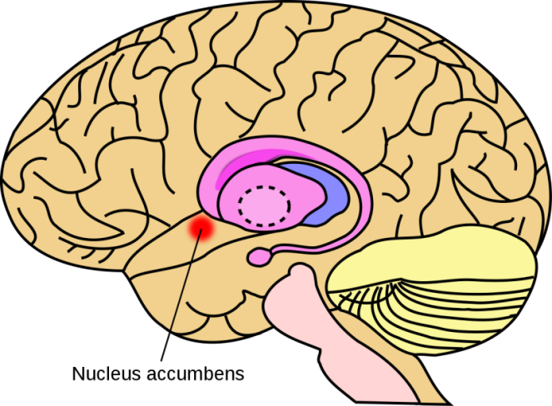
Prefrontal cortex
Associationism and learning theory arose from the question: How is it that, when I think “A”, “B” immediately comes to mind? At the practical level, when I’m presented with CUE “A”, REACTION “B” is triggered.
The link between A and B is, at first, voluntary. With repetition, the association (link) becomes stronger by REINFORCEMENT, becoming subconscious and automatic.
Neuroscience now tells us that our brain’s structure physically alters to ‘hard wire’ our habits.
Alexander uses terms INSTINCT and HABIT inconsistently. The Victorians though animals were instinctive and only humans could reason. Alexander describes fixed, automatic habits as ‘instinctive’.
Learning was thought to be according to John Locke’s tabula rasa or “blank slate” theory of the human mind. The mind starts out empty and is filled with knowledge - rather like an empty jug having milk poured into it. But it is not so. We are active agents in our own learning. We explore and shape our world. John Dewey emphasized that habits are formed by interaction between the child and its physical, social and cultural environment.
Behaviourist Theory of habit – think Pavlov’s dog and “conditioned reflexes”.

STIMULUS RESPONSE
Modern theory of habit (Duhigg)
Cue → → Routine → → Reward

Usually, the ‘Routine’ is carried out without the need to think. When we want to change a habit, the process must be brought into awareness so that we can reason and choose between alternative courses of action:
1. Shall I go ahead as usual (habit)? Or,
2. Shall I do this differently, or not do it at all (new response).

Fixed (unreasoned) and adaptable (reasoned) habits
We shall come to Alexander’s two kinds of habit later in the book.

Why is it difficult to teach the Alexander Technique?
Changing habits is not easy. It involves making choices that require mental effort!!
By nature we tend to take the easy option and avoid having to think (Thinking, fast and slow).
How do we break old associations and form new ones?
To be continued (9th July)
Reading
The Power of Habit, Charles Duhigg
Thinking, fast and slow, Daniel Kahneman
‘Erase your fear . . .’, Jessica Hamzelou, New Scientist, 15 March 2014: pp. 34-7.
MW 19/06/2020

