Manner of Use
Conditions of Use
Use is fundamental, because . . .
- Use affects functioning, and
- Form follows function
So, the manner in which we use ourselves affects our [psychophysical] functioning.
Form is not fixed and unchanging, and (within “sensible” limits) the way we use ourselves acts as a constant influence on shaping our body.
Case of “Mr. B” in UCL, p. 17f.
Arthritis of the cervical spine at your age is a "postural" disease. . . . With the onset of arthritis in the spine, or indeed anywhere, there occurs reflex spasm or overaction of muscle groups which is a vicious circle, as this very reflex spasm further menaces the deformity and increases the pain. Alexander teaches how to inhibit the reflex spasm; that is the real secret and what I have longed to do for years. . . . [Dr. Caldwell]

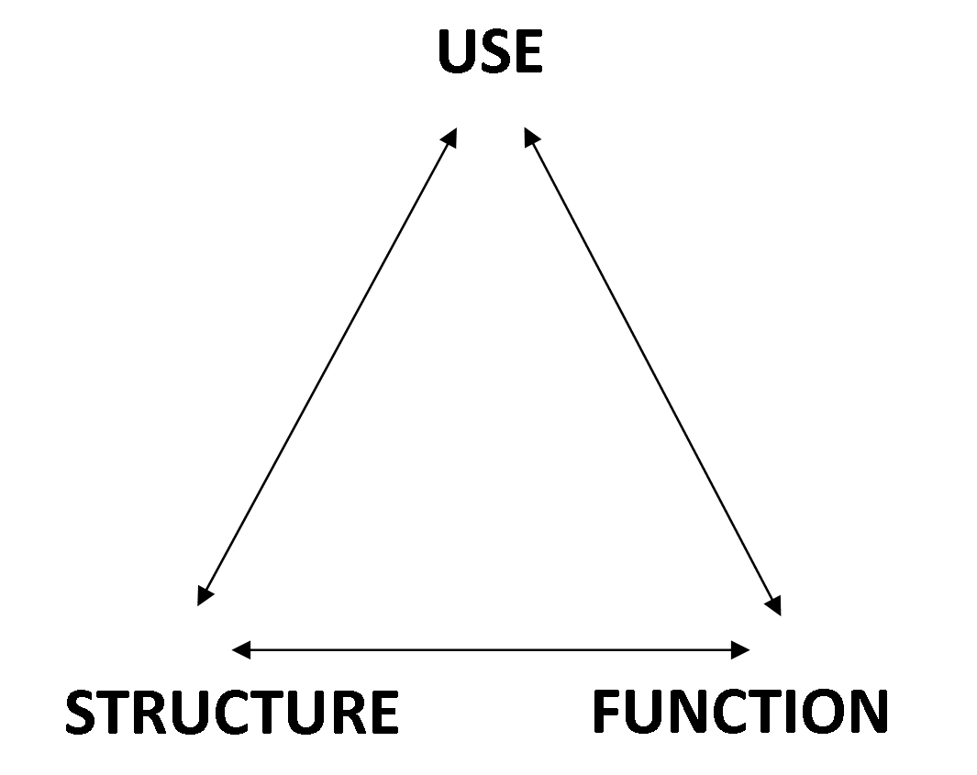
MSI, Chapter 3, Subconsciousness and Inhibition
The new science of psychology
Biology-based psychology became a specialized field in the late 1800s. Before that, the mind was regarded as separate to the body – psychic mind-stuff and physical matter. ‘Mind’ was the province of philosophy, metaphysics and religion. In 1910, readers may have thought Alexander was writing about the soul and survival of the personality after death – a popular concept of the time. This, he explained, is not what he meant.
William James was the ultimate metaphysical thinker at the cross-over into modern psychology. His method of enquiry was by introspection (subjective) rather than ‘brass instrument’ (objective) measuring, recording and analysis of data. Modern psychology was led by Germany where James studied with Wilhelm Wundt and (Helmholtz?). Prof Munsterberg became head of new psychology at Harvard. He was ostracised for being German at the outbreak of war and, probably on Dewey’s advice, Alexander omitted quoting him in the second edition of MSI.
The concept of the ‘unconscious’ was very new. Alexander used the term ‘subconscious’. There is no definite barrier between that of which we are aware and that which is hidden. William James described trying to watch his own mental processes as like, turning up the gaslight quickly to see what the darkness looks like. Of course, once you can ‘see’ the darkness or the subconscious, then it’s something conscious! Alexander built his approach on the premise that the conscious mind must be quickened!
MW 28/05/2020

